**KSHEERA**

**Problem Statement:**

Underwater Terrain is very hard to reach and very expensive to do research and organize search operations.

Many avenues of underwater marine life and oceanographic developments are not observed as widely as they are supposed to be. AUVs are used to detect life and do search operations very quickly and efficiently which would save a lot of lives and time.

**Mechanical Design:**

The design is chosen to be streamlined, as it makes the Robot

to move efficiently inside the water body.

The bot is equipped with two thrusters two present at the rear end of the vehicle to move on the x and y-axis.

For the movement on the z-axis, the bot uses the concept of Density and Volume relations.

The Vehicle moves vertically by reducing and increasing its volume.

When the volume is increased the buoyancy force is increased on the vehicle hence it moves upwards and vice versa.

There are also diving plans which further help the bot in maneuvering and control and also rudders that help in directions.

**Collection of data:**

Collection of data shall take place while the bot is present inside the water body where neutral buoyancy has been achieved the robot then covers the entire trajectory inside the water body itself, Surveying the whole area through various cameras and high-end sensors.

which takes the samples from the sensors at different locations or different time intervals as assigned earlier.

The process of taking the samples is done by using sensors and taking the water samples into the bot and taking values in a controlled environment.

The type of data collected is Image data, the Ph level of water, Dissolved Oxygen Density, and Salinity.

Also, there are sensors like the GPS sensor, Compass Sensor, 6 axis Gyroscope, and communication modules.

**The trajectory:**

The trajectory is chosen to have either a rectangular path or a circular path. The robot starts from a point where a predefined location is sent to the robot, and it starts moving from that point completing a full rectangle or a circular path and collecting the data at the same time at different intervals of the time under the water. The Robot while Moving from one point to another to collect data experiences lateral forces underwater known as underwater currents, which make it a problem as the trajectory is affected by these lateral currents and the robot could not make it to the other point to collect data. This problem is overcome by using two servo motors which control the angle of the thrust of the side thruster motors which cancel out the effect of water currents, A gyroscope module, and GPS module is used to calculate the angle of diversion and then we can make the smaller thrusters at an angle opposite to the that of the diversion and make the bot back on its Path, We have control over the pitch and yaw by using these lateral thrusters. Once the trajectory is completed the bot automatically floats over the surface and transfers the data it has collected earlier.

**The sensors:**

There are quite a lot of sensors present within the robot for collecting various types of data such as high-resolution camera feeds, dissolved oxygen levels, salinity level, pH levels, the temperature of the water pressure at the point, and for maintaining the stability of the robot there is the usage of Gyroscope and an accelerometer for maintaining the trajectory. There is a GPS module for the transmission of location.

**The received data:**

Once the data is received from the Lora module through LoRa protocols. It is then processed at a base station for further processing. The data is transmitted through a neural network which was trained on the raw data collected through an aerial survey and then giving out the probability distribution of the collected data over the Data Image of the ocean bed.

This data is processed mainly through neural network algorithms and Computer Vision algorithms to detect the and survey the anomalies in the underwater environment.

**The CAD model of the Robot:**

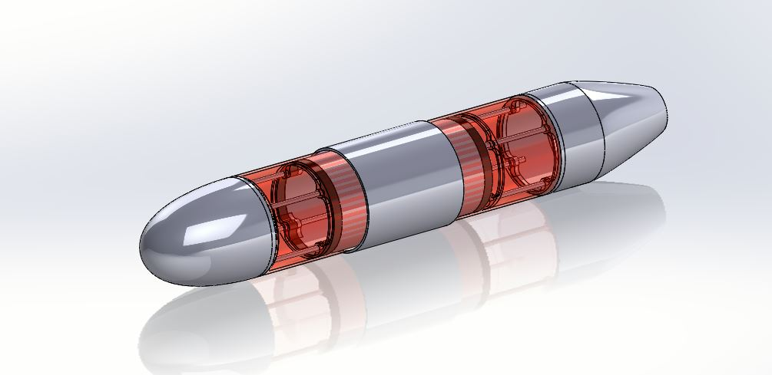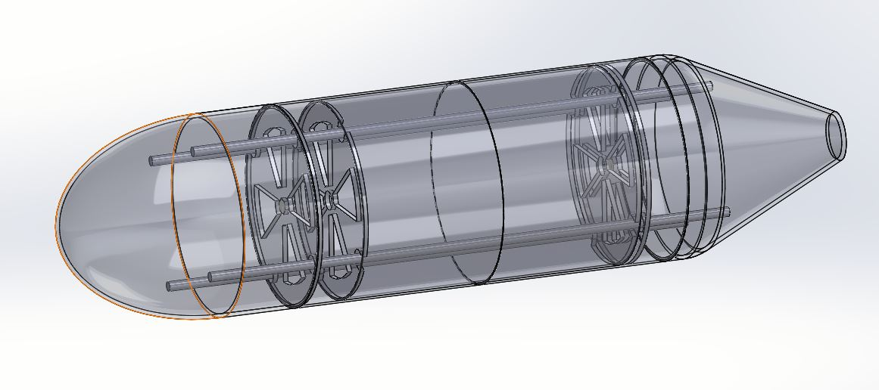

**Quick process of what is done.**

The robot dives into the water taking in various readings such as high-resolution images, dissolved oxygen, pH, barometric pressure. It processes that information and gives a probability of where the maximum number of fish could be found. So initially we choose a starting and that’s all you need to do. The rest is handled by the vehicle. It dives 5-10 meters into the water body and travels in straight lines to form a rectangle. It stops at every corner of the rectangle to collect water samples and analyze values. Once it collects the sample it turns and moves towards the next vertex. It does this ‘N’ times, thereby completing a rectangle. It analyzes the values to form a probability distribution which it displays to the user in an understandable manner.